You are given an array trees where trees[i] = [xi, yi] represents the location of a tree in the garden.

Fence the entire garden using the minimum length of rope, as it is expensive. The garden is well-fenced only if **all the trees are enclosed**.

Return *the coordinates of trees that are exactly located on the fence perimeter*. You may return the answer in **any order**.

**Example 1:**

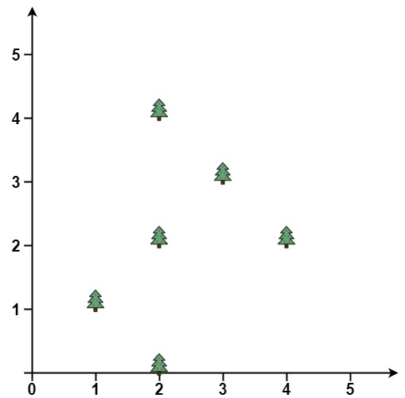

Input: trees = [[1,1],[2,2],[2,0],[2,4],[3,3],[4,2]]  
Output: [[1,1],[2,0],[4,2],[3,3],[2,4]]  
Explanation: All the trees will be on the perimeter of the fence except the tree at [2, 2], which will be inside the fence.

**Example 2:**

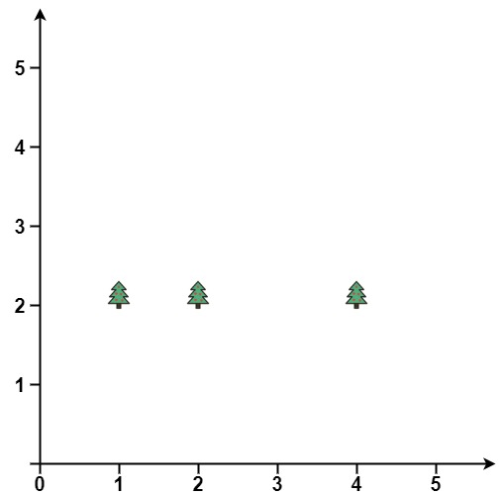

Input: trees = [[1,2],[2,2],[4,2]]  
Output: [[4,2],[2,2],[1,2]]  
Explanation: The fence forms a line that passes through all the trees.

**Constraints:**

* 1 <= trees.length <= 3000
* trees[i].length == 2
* 0 <= xi, yi <= 100
* All the given positions are **unique**.